IY5612 Cyber Security

REVISE CII

**Unit 1 - Critical Information Infrastructure**

Early = Cyber war (military ops on info & info sys)  
 = netwar (influence population op & actions)

Cyber warfare = actions by nation state to penetrate another nation’s computers/networks for PURPOSE of causing damage/disruption

* May constitute act of war
* Cyber ops conducted alongside or in preparations of OPS in other domains (air land sea)
* Estonian info sys
* BUT Russia vs Georgia (2008) attacks launched agst gov, commercial IT sys, parallel with kinetic ops
* No open ack, until May 2016 of US CyBERCOM against IS in Iraq

Cyber Conflict (not espionage or intel ops)

* Nations enaged in cyber ops, CI concerned
* Attribution = key problem
  + Based on recognizing patterns
  + attractive in asymmetric conflicts
  + ops = can deny
  + forensics analysis = hard, when counter forensics, given risk of false flag ops (Y wants X to atk Z)
  + entities (can claim resp) even for non malicious incident
  + retailiation against non-agent of state = non-combatant civilian

Bounds between peacetime, shades of conflicts, outright war = blurred

Protect Civilians in armed conflicts

Critical infrastructure = part of armed conflict

* strategic bombing in WW2
* ASSET/SYSTEM essential for maintenance of vital societal functions, health, safety, security, economic or social well being, disruption == significant impact (if fail to maintain)

Non-state actors = important in cyber conflicts

* US doctrine = lawful to use force in self-def

UK = 14 sectors  
- comms  
- financial services  
- gov  
- emergency services  
- health  
- water  
- energy  
- food  
- transportation

Most modern infra = dependency on info sys to provide services efficiently

CPNI (center for protection of national infrastructure) = services provided, not delivery

CII = interconnected info sys + networks, disruption/destruction of which = serious impact on health/safety/security/economic well being, or functioning of gov/economy

* Includes invisible = embedded sys, process control sys

Asset Identification

* Identify = insufficient without understanding (how assets constitute indiv sector)
  + some sys = hard

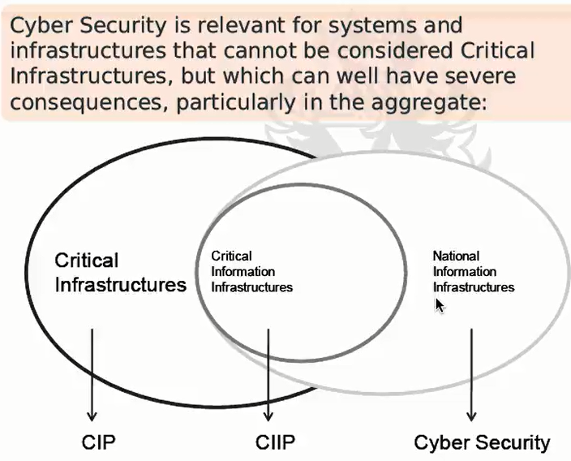

Smart cities, Smart factories, IoT = dependency on cyber-phy components & connectivity

* heavily optimized = no fallback

Mirai botnet = used IoT devices, went in using default cred

Threat Sources  
- person/org desires to breach security (benefit from it some way)

Threat Actor  
- person who actually attack, case of accident, cause it

Can be insider as well.

NOT considered

* technical failures (can be exploited delib)

Considered

* higher end of spectrum of adversary sophis
* target precisely, (can beyond a single immediate objective)
* Threat level = combination of capabilities + motivations of threat sources/actors

Threat Actors = not isolated category

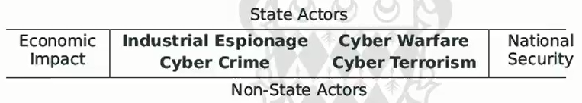

Hybrid = attractive = advanced threat agents

Cyber space = interactive domain, made up of dig network, store, modify, communicate info. Includes internet, info sys, that support business, infra, services

Accidental disruption = resilience , nt security

Cable outage (measured in days/weeks)

* Limited number of ships/equipment
* Positioning ships, permit from nation
* Equipment faults/ earthquakes / human err

Trans border data comms = fibre optic, sub-sea

Sat comm = extreme niche

Tapping comm cable = not new

Operation IVY BELLS = targeted soviet sub-sea cable

* Comm unencrypted
* Interception device
* Signal = electromagnetic, induction coils wrapped

National Security Strategies

* Range of issues, some law, some constitution req
* Roles/ responsibilities of security
* UK = strong centralised approach
* Crucial = identify and PRIORTISE areas of concerns
* Directly/indirectly identify adversaries

**Unit 2 - Complex Attacks**

Threat actors (with resources):

* State actors, seek intel, ability to exfiltrate info (CNE, computer network exploitation)
* State actors, offensive ops (CNA, computer network attacks)
* Non-state actors, straightforward objectives, but with resources

Basic (Opportunistic) Attacks:

* may have knowledge of vuln, possession of exploit of target
* objective = compromise any system/user account
* Opportunistic targeting = effective strategy
  + Used directly for financial/ identity theft/ blackmail / reuse
  + Springboard for further attacks

Kill Chain (6 steps) Concept:

* Targeted, intel driven
* Find, fix, track, target, engage, assess

Cyber Kill Chain (7 steps) Lockheed Martin

1. Reconnaissance (research, identification, target selection, open source intel)
2. Weaponisation (Remote access mechanism, exploit, deliverable payload, automated tool)
3. Delivery (transmission to target environment via electronic channels, also removable media access (air-gapped), insider(cooper/unwitting)
4. Exploitation (adversary code triggered, multiple stage, evasion, obfuscation, escalation)
5. Installation (attain persistency, and obfuscation, e.g. rootkit)
6. Command and Control (updates, instructions, exfiltrate info, manual interaction channel)
7. Actions on Objections (principal objectives, lateral moves, further application of chain)

APT

* NOT degree of sophiscation of steps
* SYSTEMATIC employment towards more complex objectives (long term)

Understanding above = allow defenders wider view of attack lifecycle

* Organize artefacts during investigation
* Inverting adversarial asymmetry ( remain covert during stage of operation)

Cyber kill chains = INTEL driven

* Deny intel = critical
* Intel gathering effort may be monitored
* Finding weird/disjoint friends on employees

Battlefield Terrain Analysis

* Defenders should know terrain they are defending, while attackers must discover it through recon
* Defender exploit attack lack of knowledge of terrain = delay from iterative analysis
* Elements
  + Observation and field of fire (visibility of network, systems, users)
  + Cover and concealment (some hard to obscure)
  + Obstacles Key Terrain (hardening systems and networks, network topo)
  + Avenues of Approach (likely pathways adversaries might use)

Counter cyber kill chain

Weaponisation = stage cannot be observed by defender (may be defended/detected)

* Zero-day attacks (code may be re-used, anomalies results from delivery)
* Delivery mechanisim (spear phishing, IDS)

Once exploitation/installation = progressively harder (silent for a long time, concealing entry paths)

APT = users of kill chains

* Initial compromise = highly targeted via tailored malware/ spear-phishing
* Require C2 channel
* Persistency = repeated attacks along different avenues, where initial attack discovered

Deception and Dissimulation

* APT will involve human in the loop
* Human = not good detecting deception
* Defenders may benefit V from adding deception and dissimulation into their asernal (static/dynamic)
* Adversary visible functionality of system and perceived state
* Can distract and give valuable info
* Honeypots, honeynets, honeyfiles, honey records, honey users

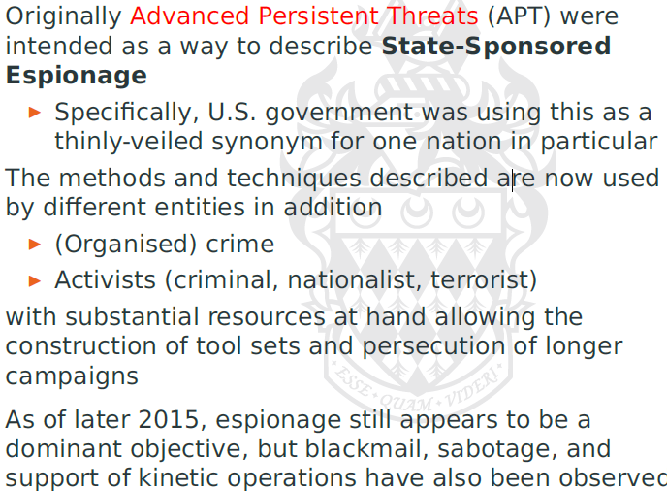

Case studies

Aurora campaign = uses common pattern for attacks (watering hole attack)

**Unit 3 – Network**

Robust Network – why? single line of failure, incorrect orders issued( (US Nallistic Missile Early warning sys down)

Network = flow of resources, whether physical/logical

Understanding security = right abstraction level

* Design of crypto = use high abstract comm model, not capturing interesting aspect
* Studying protocol at implementation level = obscure effects + behaviour

Representing (collections of nodes(vertices), and connections(edges))

* Adjacency matrix
* Incidence matrix

Graphs = set of vertices and set of edges  
Neighbour set = set of vertices adjacent to V  
Degree = number of edges wth a V  
Subgraph = subset of main graph, but all edges must have vertices

Induced subgraph = take all the edges that are connected to the vertices (selected)

Isomorphic graph = all edges = unique

Walk = seq of edges  
Trail = distinct edges, and a path with distinct vertices  
Cycle = trail of distinct vertices, with V0 = Vk

Correctness = all distinct vertices are connected  
Component = where H is connected and not contained in subgraph of G, with more vertices and edges

Vertices/Edges Cut (minimal cuts to reach component)

k-connectivity = minimal set (G) >= k, then k-connected

Edge/Vertex independence

Menger’s theorem. – min number of edge cut that disconnects u and v = max number of pairwise edge-independent paths between u and v

* G = k-connected (if and only if) 2 distinct vertice are connected by at least k-vertex independence paths
* G = k-edge connected (if and only if) 2 dstinct vertices are connected b at least k edge-independent paths

Collary = 2-edge connected graph lies on a cycle

Directed graphs = tuple of verices and a collection of arcs (u->v) that joins a vertex

* Directed walk = alternating seq of arcs
* Directed trail = directed walk with distinct arc
* Directed path = directed trail with distinct vertices
* Weighted Graoh
* Dijkstra’s algo (single source, shortest path, non-negative path, shortest-path tree)

Circuit = undirected graph, u=v and that traverses each edge

Euler Circuit = circuit which all edges are traversed exactly once

Hamilton path = path that contains every vertex of G

Hamilton cycle = cycle containing every vertex of G

* Travelling salesman problem (lowest cost of cycle)

Distance stats (of shortest path)

* Eccentricity = how far a node is from the node most distant from it in the graph
* Radius = min eccentricity
* Diameter = maximum

Average path length = average length of shortest path from u to other V

Characteristic path length = median over all (average path length)

Vertex Clustering C-efficient = way that neighbouring vertices are connected to each other

* Counting the number of edges with the immediate vertices
* No. of neighbours am I really connected to that I could possibly connected to.
* measure of the degree to which nodes in a graph tend to cluster together

Graph Centre and Vertex Centrality

* centre = set of vertices with minimal eccentricity, VC = 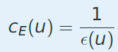

Closeness Centrality: how close given vertex to all other vertices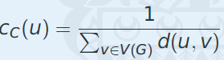

Betweeness Centrality: determine chokepoint, consider removal of a vertex that would significantly increase distance between other vertices

Random Graphs = where edges between vertices exists with probability P

Erdos Renyl Graph = random graph (can have multiple edges/loops with same vertices)

* probability p
* degree distribution = stochastic variable
* median = mean
* average path length = 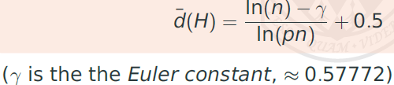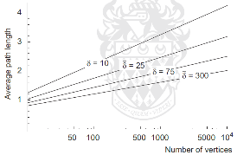
* Clustering coefficients = p
  + Expect num of edges between k neighbour = 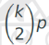, max = 
* Increasing p = vertices in same component (giant component)
* 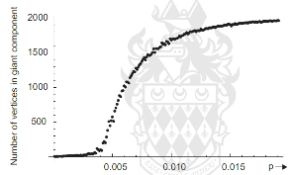
* Average degree k = 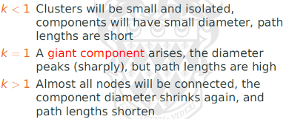

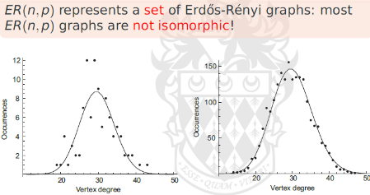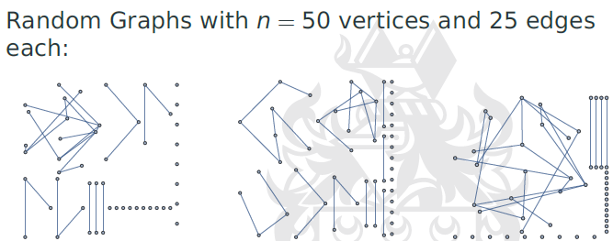

**Robustness – fraction of vertices or edges need to remove to partition graph**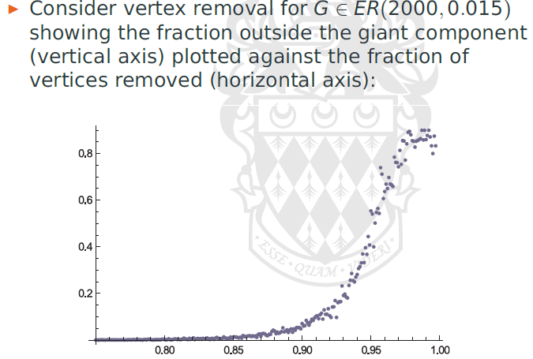

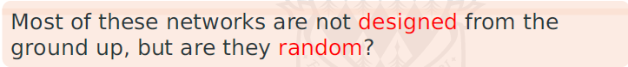

Example networks

* rail (not random, degree distribution != poisson)
* social network (not limited by physical constraints, not random)

2 properties of primary concern:

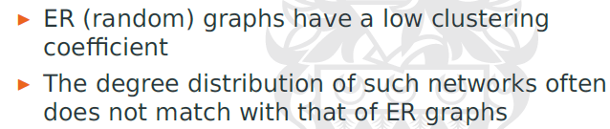

Small world = 6 degrees of separation

Shortcuts (rewire regular graph)

* limitation of construct = implies fixed number of vertices and relatively homogeneous degree distribution = side effect

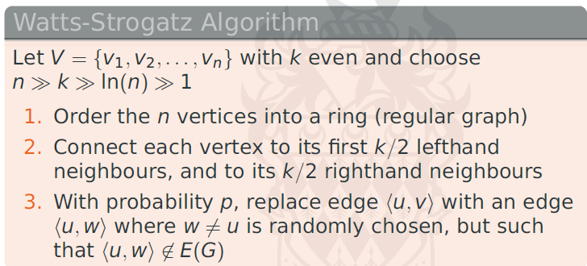

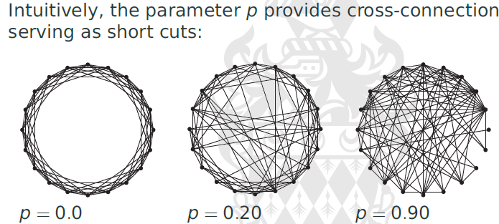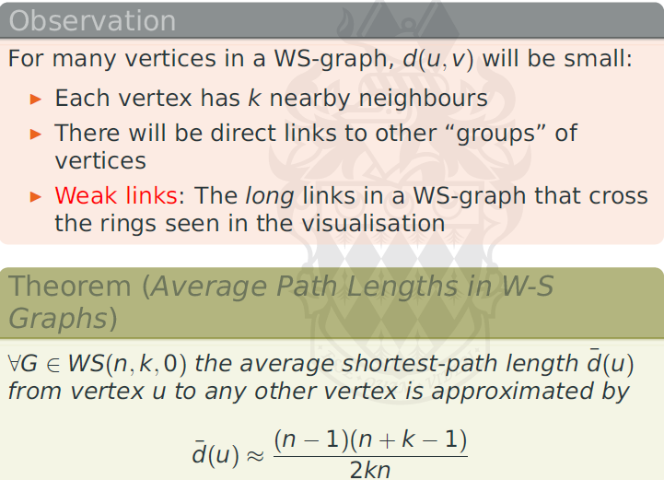

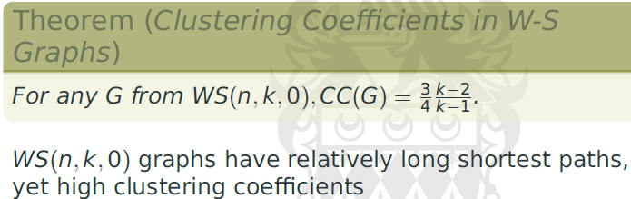

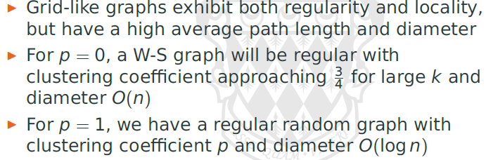

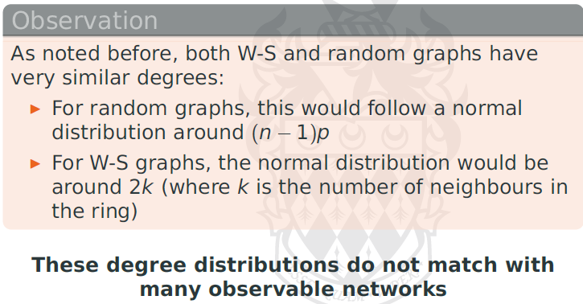

**Scale Free Graphs**

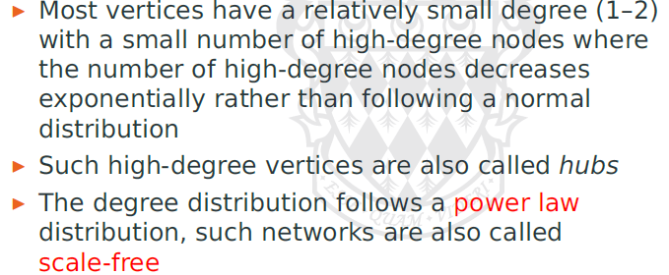

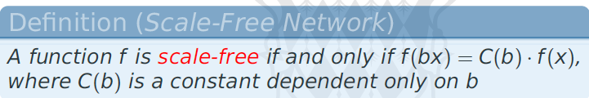

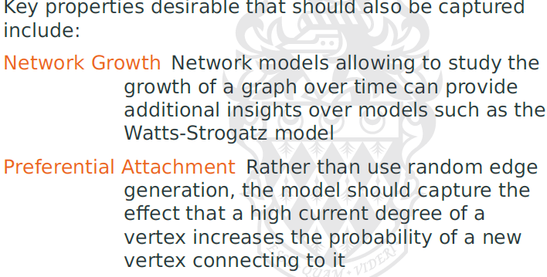

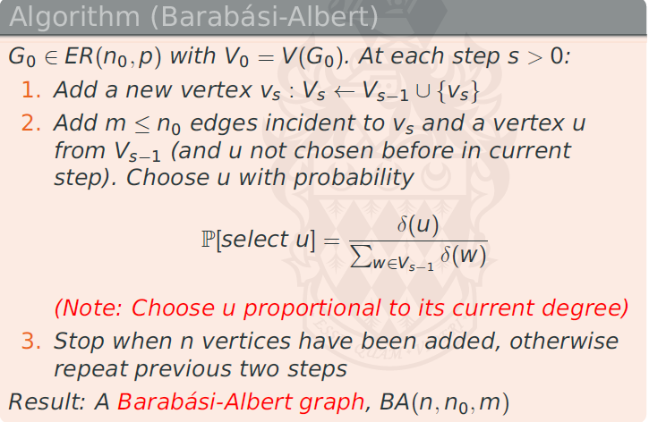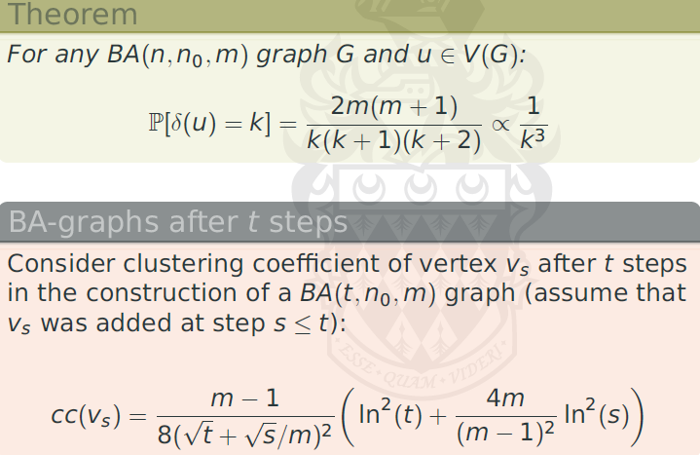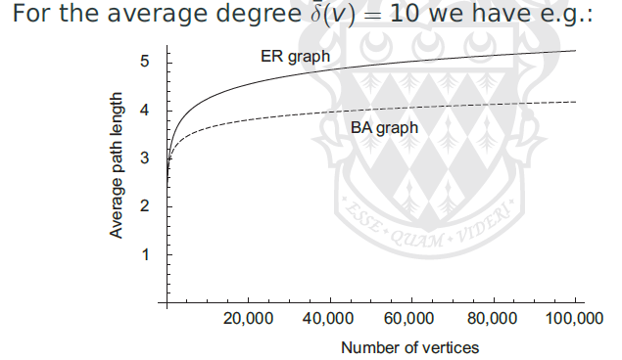

**Modelling Internet**

BA and other models = obtain accurate structural network models

* biological – social = social free structures
* different scales, models not accurate

Structured network = deliberate redundancy, avoiding typical hub

(Distribution != smooth)

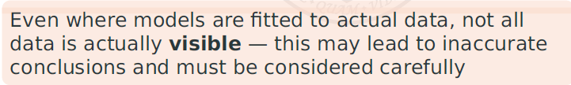

Robustness of network models != robustness of internet

BGP (Border Gateway Protocol)

* requires Autonomous System(AS) number, by IANA (more than 42500 advertised AS)
* Each AS connect to >= 2 AS, must advertise accessible network

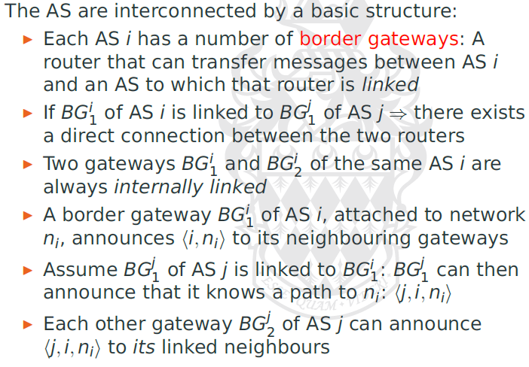

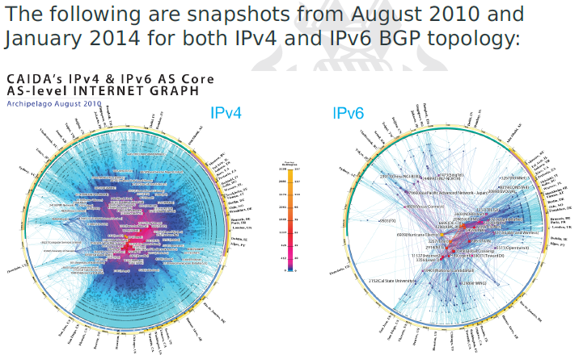

Idealised = 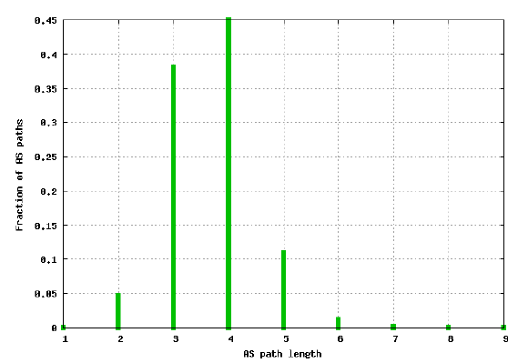

But Norway to Australia = 16 hops

Real AS = commercial/practical consideration (preferred route for $/cooperation)

* Decision at policy level (may change, not captured in static model)

Withstand vertex-disjoint = **PATH DIVERSITY**

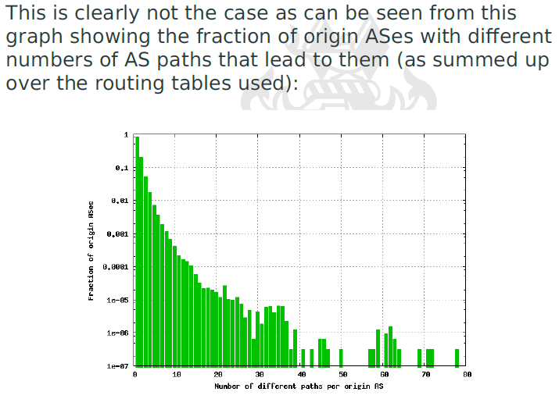

Menger’s Theorem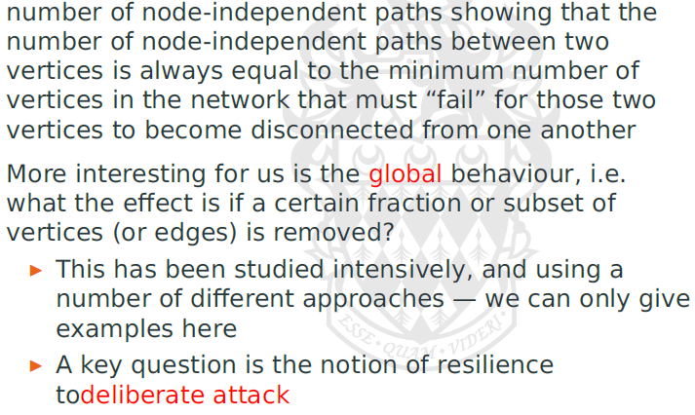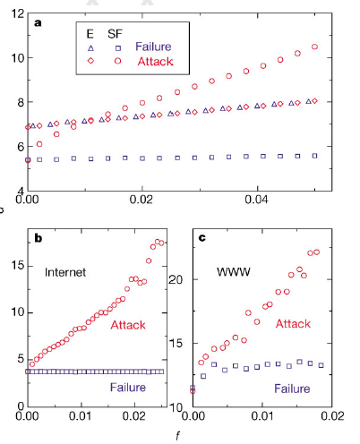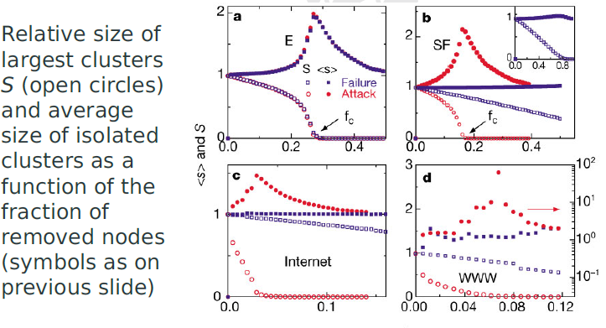

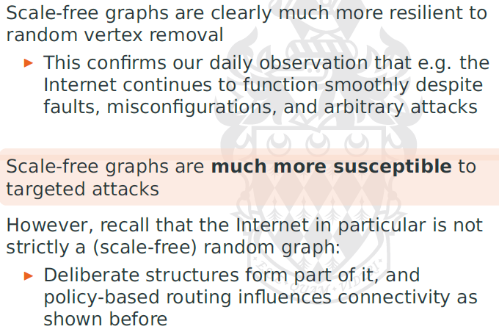

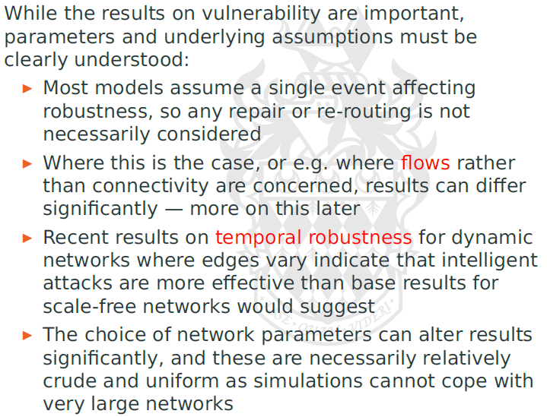

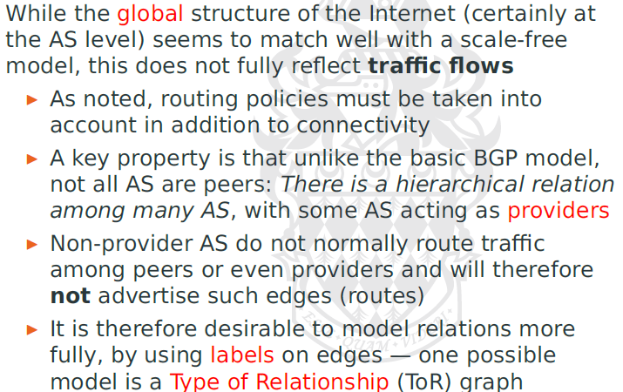

Structure might be scale free, but traffic flows != same

* Routing policies, in addition to connectivity
* Not all AS are peers, some as providers
* Non-providers, don’t route traffic (not advertise edges)
* 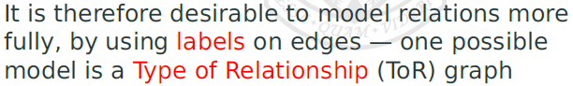

Looking at TOR graphs

* Tier 1 need to form full mesh (evident from observation)
* Multiple hierarchical levels of AS (cross connection = rare)
* Resilience to faults = redundancy needed, but edges = minimized
* NP hard problem = max number of vertex disjoint paths for constant k

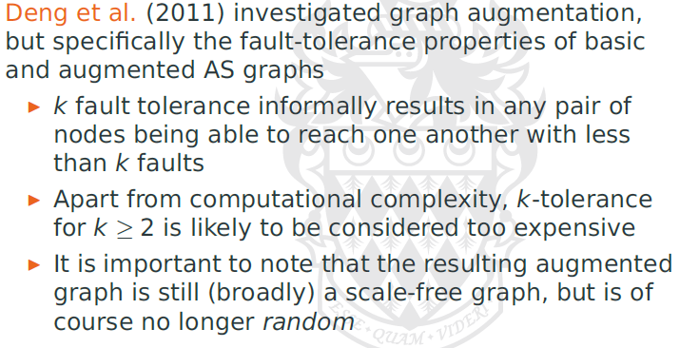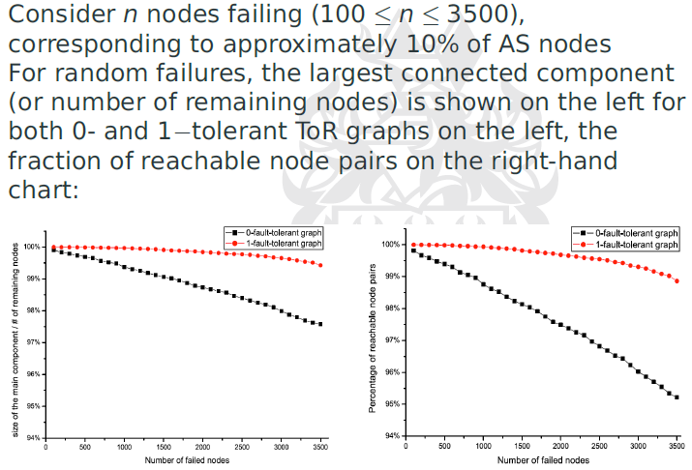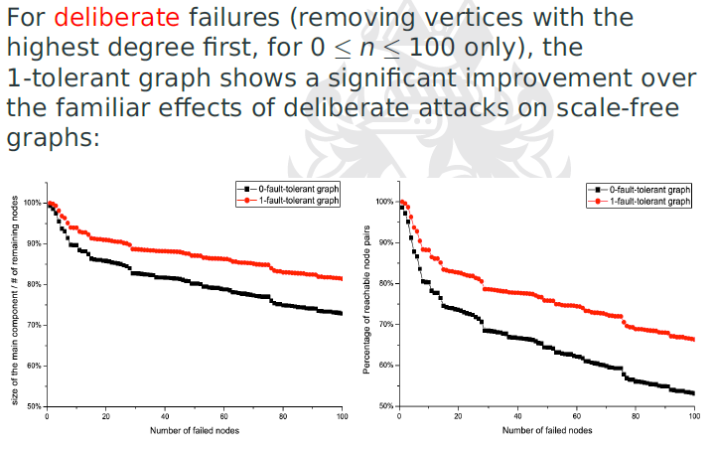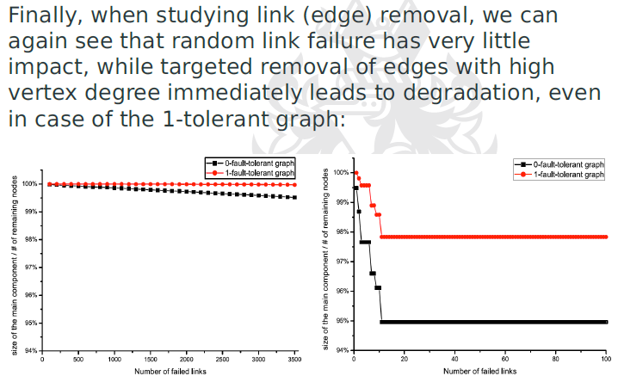

Study of structure of network

Allow characterization of the network

Permitting the study of structure, otherwise not visible or accessible, in some form of algo or simulative approach

Unit 4: Interdependency

An attack = affect dependent nodes, need for protection

**Identify dependencies**  
- relations are captured in graph, only simple transitive properties are assumed (straightforward)  
- **cycles = interdependencies**  
- graphs = include loops and weights

Considerations = limited to same abstraction level

e.g. national security = infra sector, state/supranational entities, public  
MODEL = qualitative analyses + macro-econ models

e.g. legal = infra sectors, intra-sector actors, external entities  
MODEL = Qualitative analyses and (qualitative) econ model

e.g. Technical = trans-sector + sector-specific tech sys  
MODEL = qualitative + high-level quantitative model

e.g. System = smaller scale technical+organisation sys, interactions, infrastructure sectors  
MODEL = qualitative, quantitative models, substantial technical + organizational fidelity

**Modelling Scale for CI network**

National security, legal (beyond) scope of what can be modelled

No. of params influence what can be modelled:  
- understanding of modelling object  
- availability of quantitative data (highly sensitive to choice of params)  
- used for prediction/simulation = limits granularity + complexity of models

Models = capture different scales, rare if >1 levels

Part, Unit, Subsys, sys, infra, interdependent infra

**Input Output models**

Economic dependencies = interest ranging from CI in region or country or within organisation

* Relations among sectors captured as input/output (Set of linear equation)
* Sector i produces Output x, each unit requires a units from Sector j
* Sectors = interdependent = producing/consuming output

**Output of sector =** an equation of the required input, as well as the required output in desired demand vector

**Extension = Inoperability input-output(IIM)**capture level of dysfunction relative of nominal state  
- extended multiple times (dynamic effect)  
- IIM/DIIM not limited to cross-sectoral models, used in Infosys  
- **understand impact of failure**- limited use in capturing malicious effect  
- capturing deliberate attacks (disrupting caused by cyber attack, steady-state & cascading effect = interest)  
- limitations from the “need to know exact relationship between IO”, “rely on linear model”, “single metric to optimize”  
- contradicting objectives = may exist

**DIIM Dynamic IIM**

* Common in discrete, also time-variant
* Useful = understanding risk, impact of interdependencies
* Characterisation of resilience
* Understanding the buffer

**IIM = basic, static** in nature, not consider perturbation, arise from natural disaster/deliberate attack

**Cost of resilience**

**<**image>

**Steady State Graph Model**

* Knowledge of network struct = give impt insights into potential vulns
* Not limited to actual network
* Precise mechanism = not necessary to capture dependency/interdependency
* BUT, criticality of the node (difficult to spot)

**Dependency Graph Model**

* Variant of centrality measure for graph (pagerank metric)

E.g. Debt rank

* Identify largest borrows, relative to asset size  
  interconnection with other institutions
* Interconnection = Critical as institutions = crosslinked by transaction, holding equity, and debt of one another
* Nodes at centre of graphs = maximum potential impact
* Cyber physical sys = more in-depth view of connections
* Multiple components linked by com and network = require understanding of network topo = static + dynamic effect
* Sys of interest for cybersec = also contains dynamic components (topo, interactions) changing over time

**CI interdependency model**

**Graph based models**

Interested in (interdependencies) = directed graphs  
- dependency graph, assigning weights, other properties/attributes  
- attributes = abstraction of lower later models

Basic Model

Robustness of network  
- reduce possible chains of dependencies = desire  
- minimize indiv path or graph diameter

Basic graph properties = useful info  
- k-connected = no. of simultaneous failure can tolerate  
- degree distribution of graph  
- cut edges (minimal to cut graph) that are not k-connected

**Centrality**  = metric for proximity of node to all other nodes

**Betweeness**  = total no. of possible paths through a node

These properties = surprising + not obvious

Computing metrics= expensive O(n^3)  
- butttt interesting to study dyn behaviour of network  
  
Study attacks = highest betweeness (as likely target), and how is it distributed

**Clustering Coefficient**

* Can see how close graph is connected
* Local clustering = how close to form a complete graph

**Local clustering**

* Fraction of edges between immediately connected neighbouring vertices divided by number of possible edges
* Distinct for direct & undirected graph

**Robust in Scale Free networks**- degree distribution = skewed to most vertices with small degree  
- average (local) clustering coefficient and centrality metrics = relatively low

**Network Robustness**

Discussed connectivity only  
- but we have capacity/load (like electric, com networks)

**Study of flow problems**max flow from one (source) to another (sinks)

Flow F to be considered legit, **capacity constraints** = considered, and **flow conservation** is required.

* Minus the flow when a path go through it

Add up all unused = **Residual network**

* Simplest = Integral flows with 1 flow and one sink
* Algo, track all the paths, and deduct capacity when it goes through

**Ford–Fulkerson algo  
-** find the min cut  
- capacity of cut = c(S,T)  
- min cut = cut with min capacity  
- min cost of disruption = max capacity loss

Exceed capacity = congestion/overloading  
- congestion = decreased overall throughput  
- requires buffers.  
e.g. electric grid (physical laws with power flows)

**Cascading Failure**

* Com networks, electric, financial = prominent
* Failure when >=1 vertices/edges = causing flow to make others overload
* Search for alternate flow routes/ inefficiencies = disruption (need further activity on network)

Requires understanding relevant flows, dynamic

* Will usually not settle equilibrium state (After disturbance)
* Capturing dyn changes (time sensitive)

Compensation = Not only redistributing, often less efficient **workarounds**

* Flows = must redirected, reduce capacity

**Attack strategies minimizing cost of adversaries**

**Agent based Models**

* More complex interactions (cant just use weights)
* Can include physical processes (approx. social agents)
* Require precise behaviour, current state, external influence
  + Not completely know
  + Controlled by adversary = not know the behaviour
* Used in simulation (for understanding under usual circumstances)

Tor network = overlay network (provide privacy, anonymity)

* Hide client, location, providing alternative access path to blocked service
* Distributed group of indiv, that mix traffic
  + If enough adversaries = mixing = imperfect (nation states)
  + Anonymity = extremely critical

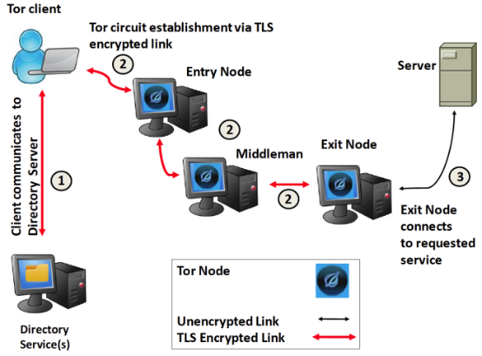

Principle of onion routing

* Intervening nodes forward traffic, limited info on predecessors
  + ATKers Seek to block access/ remove anonymity
* Can also false entry guard
  + Affect ability/preference to pick entry guard
* Change guards too frequently = DOS, too rare = compromised guards

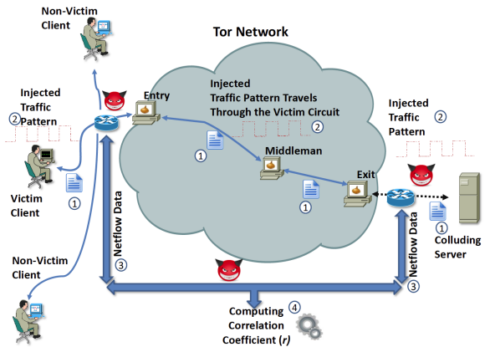

Modulating traffic to identify target.

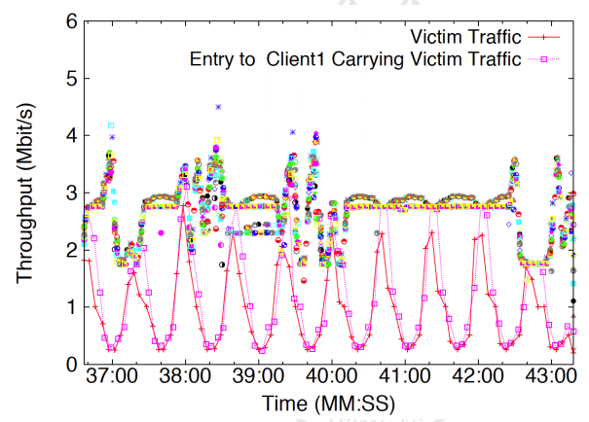

Capture interaction

If use CONGESTION CONTROL

Defector = benefit from not following protocol  
once many nodes ignore protocol, everyone loses

Prisoner’s dilemma

**Game Theoritical Model**

Conventionally,   
Adversaries = behave in a way is optimal

However,  
Adversaries follow strategies that are not optimal  
Behaviour = information incomplete

Key Question = OPTIMAL deployment of resources

* Risk assessment (adversaries can observe and adapt strat to avoid security)
* Use of Stackelberg competition = attractive

**Electric Grid & interdependencies**

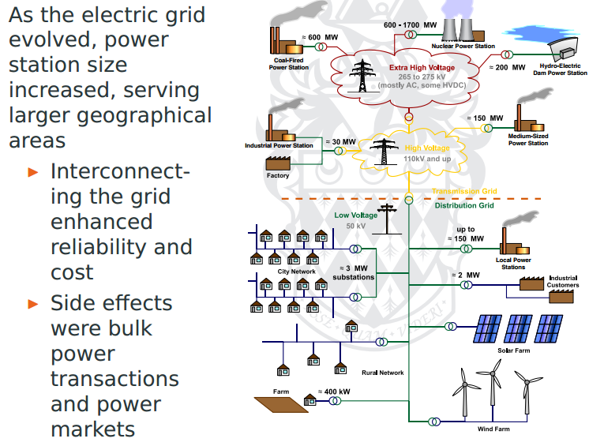

**Consists**

* Generators
* Transmission grid
* Distribution grid
* Customers or LOAD

**Need to balance supply & demand**

= biggest manmade machine with components at continental scale

* Grid operators = maintain frequency
* Demand/Supply fluctuate over time

Dynamic view of power grid

* Data = trading spot power & future, monitoring
* Frequency = maintained in narrow bounds
* Balance with neighbouring countries

**Transmission Grid**

Transmission lines = power station to substations  
Interconnected to provide flexibility & redundancy  
Grid = sparse, cost, configured in ring/mesh  
Faults = critical

**Interconnections**

Requires communication for ops

* Operators = observe demand/faults/comm with generators & load = maintain balance
* Parameters = observed
* Comm = realtime
* Communication = proprietary network (can rely on existing network)
  + Attacked = limited tolerance = cascading failure

Function = **State estimation** to **Load forecasting = automated**

Integrity of sensors, availability, reliability, realtime req

Recovery = require dispatching staff to remote (islanding)

* **Mobile phone network =** very limited power backup
* **Which network = target = maximize extent & duration of failure**

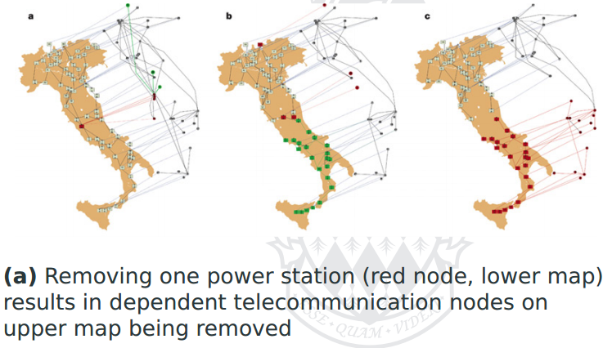

**Models =** provide both attackers and defenders understanding of risks and threats in network (not visible when considering components in isolation)

**Unit 5: Cyber-Physical System and Control Systems**

Most CI (except finance) = substantial physical aspect

* Majority of CPUs = embedded systems
  + Disrupt these = damage = loss of life

**Terminology**

* **Process =** a (set/sequence) operations to transform input into output
* **Manipulated Variable =** MV = variable = parameter of a process manipulated by control system
* **Final Control Element =** component change value of MV
* **Controller Output =** signal from controller to FCE
* **Process variable =** variable changing in response to changes in MV
* **Set Point =** value at which PV to be maintained (temperature on thermostat)
* **Actuator =** mechanism translate controller output into physical change
* **Detector =** physical parameter to measured variable
* **Transducer =** Device convert receiving info format to another
* **Transmitter =** transmit signal
* **Controller =** operates automatically to regulate a controlled variable

**Process Control Process control** = act of controlling **FCE** to change **MV** so as to maintain **PV** at desired **Set Point**

**Simplest =**  open loop control

* **Relies** on **Model** of system
* **Current state** of the system
* **Does not rely on feeback/sensors**
* Suitable for predictable/non-critical
* Stable, will maintain in absence of disturbance
* Diagram
* E.g. Toaster (calibration = required)

**Dealing with disturbance = desired  
Closed loop/Feedback-loop**

* PV = measured by senors (measure diff between desired & measured PV)
* Diagram
* Feedforward = possible (harder)
  + Effects of disturbance must anticipate

**Control System Design**

* Assume sensors/actuators = free of faults/errors
* Comm = free of faults/errors

Designing the controller = hard

**Elements**

**Modelling –** modelled and simplified, control laws = identified **Analysis –** Steady state, transient time response, frequency, stability, robustness of control law **Design –** control system = feasible & cost effective

**Simplification =** necessary element  
Key problem = **process dynamics**

* Response behaviour = not instantaneous
* Dead time = lag
* Feedback = delay, lead time before effect

Important concept = **GAIN**

* PV change proportionately to MV = constant k = gain

Any model = approximation,

* Simplest, controlled sys = well understood, can describe using linear
  + Mechanical system (not operating outside parameter)
* Non-linear system = frequently avoided

Models = exhibit errors  
Control system’s Function/efficiency:

* **Ability to determine = process change = genuine (limitation, flaw in model, fault in sensor/actuator or deliberate attack)**
* Model = detect deviation (errors)
* Need for explicit state/mode change modelling
  + State space model = required

Real process/control system = not possible to analyse exhaustively

* Well defined parameter = considered. Some input have random influence = cannot be expressed analytically

WHAT happens from deviation from steady state

* Control system = respond to stimulus/ internal state change

For given state change, control state in response = exhibit undesirable behaviour

* PV = overshoot/undershoot
* Corrections = oscillations
* Oscillations = damping characteristics
* Strong damping = not free (time).   
  Limit speed/magnitude control sys can respond  
  Influence = settling period
* Result oscillation = ringing

Control Limitation

* Requirement of ringing = cannot recover automatically within time
* Undesirable states = input outside the specs, control system cannot respond
  + Delayed measurements
  + Bad sensors

**Observability**

* System = observable, IF current state can be determined in finite time, using only output var for any possible seq of control/state vectors
  + Detactability  
    unobservable state = stable

**State Controllability**

* Obtained if external input can change the internal state of sys from initial state to any desired finite state, in finite step seq
* Output controllability = only care output
* Zero dynamics = output->same, internal->change

**Nonlinear Control**

* Do not allow **superposition**
* **Multiple isolated equilibrium** (linear = have one)
* Have **finite escape time** if unstable

**Process Control System**

* Single site, modest complexity (input/output var)

**Programmable Logic Controller**

* Integrated I/O facilities, in hostile environment, simple operating environment, single loop
* Not connected to external systems (not subjected to external attacks)
* Bus/ point-to-point protocol
* Relate input to output (using ladder logic)

**Basic RTU control systems**

* Usually connection = 1km, need longer
* Remote Telemetry/Terminal Units
* Original = I/O with comm, not programmable
* Now = overlap with PLC

**Control System Interface – HMI**

* Must configure
* Simple system = require minimal interaction
* Commands/programs/datasets = complex, require access to data sources
* Run on general-purpose computer
  + Vulnerable
  + Vendor = may not qualify newer OS
* Advanced HMI includes
  + Monitoring, manuals, diagnostic, states, performance
* Include topo diagrams of PCS

**Network Components**

* Serial line = more expensive than structured network
* Exchange more info with PCS beyond HMI = really good
* **Field bus**  = not routable
  + **No security present, integrity only**
  + Safety, reliability, redundant cabling, real-time properties
* Differ from standard networks, NOT TCP/IP
  + Light protocol

**Data historian**

* DB collecting parameters for OPS/PERF
* Need to interrogate sensor states
* Main = generate report, repo for queries
* May provide alert

**ERP**

* higher order control system

**Supervisory Control and Data Acquisition (SCADA)**

* various PLC/RTU, system, cascaded, hierarchy

**Air Gap**

* main focus = safety & reliability
* trusted operators, no physical connection between networks (wireless included)
* RTUs operate over variety of media, including dedicated line, radio links. (no TCP/IP)
* **Dial-up** facilities (modest access control)
* **Not true**  (more and more)
* Commercial value for information flow
* Even if true, regulators requirement = subverted
* Modified equipment for passive/injection of command and control info
  + If supply chain not secure/access not monitored = hard to detect/prevent

**Real time Requirements**

* Exact req = vary, speed!=relevant, time is critical
* Characterised by ability to tolerate missed deadline
  + Most demanding = hard
  + Can tolerate, but degrade = firm
  + Can tolerate, still usable = soft
* Total correctness depends not only on logical correctness, but also time within operation, and failure to meet deadline = total failure
* Bounds on jitter
* Jitter = (undesired) deviation from true periodicity of ideal periodic signal.
* Worse = wandering signal
* General purpose OS != real time system
  + = pre-emptive multitasking sys (no guaranteed response time)
  + Bg tasks = hard to determine worst case

**Real time OS**

* Efficiency (minimize latency, predictable)
* System calls (non-preemptible sys call = brief, deterministic)
* Scheduling (deterministic scheduling, prioritisation)
* Priority inversion (must control as it results in resource starvation)
* Memory management (usually no virtual memory, no paging effects)
* Vxworks, eCOS, RTLinux, QNX, pSOS

**Real time constraints**

* Java/c# = GC (clean up mem periodically)
* May violate real-time constraints
* Easily violated = security-related patches = may cause harm, unless qualified

**Attacks on Cyber-Physical Systems**

* Not perfect binary abstractions
* Sensors & actuators may fail (in different modes)
* Wear & tear expected, degrade PERF
* Operate on PERF envelope
  + Reliable = within param range

**Accuracy =** (distance of measurement from true)

**Precision =** (degree of which repeating, = same results)

**Repeatability =** (short term repetitions = same)

**Reproducibility =** (same results with different measurements/ long periods)

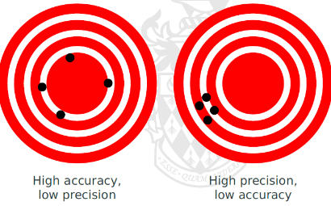

**Error**

* Error = random, normal distribution
* Some = characteristics of sensor (change over time)
* Can manipulated to fail, not provide readings

**Bias** = deviate from mean value

* Compensated through calibration
* Physical manipulation of sensors = result in bias
* Difficult to detect
* not easily characterised

**Physical manipulation = problematic**

* some manipulation = difficult to attack from diagnostics
  + require actual physical inspection
  + thousands of sensors, difficult/dangerous to access
  + physical security = hard for insider threats
  + manipulation before entering site (supply chain integrity)
  + sensors = Processing unit = more flexibility for attackers

**Attack Sensors**

* intelligent = enable attackers number of attacks. (cannot be detected by simple statistical tests)
  + apply functions to sensor reading
  + provide arbitrary readings
  + omit sensor data
* Preconfigured = not require sensor manipulated externally
* Can apply to **actuators**
  + Change **gain** achieved by actuator
* **Attack =** Fail after certain number of operations, restrict range of actuator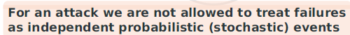

**Desynchronization Attack**

* Most severe (loss of view & control)
* Loss of view (may not be distinguishable) to complete failure
* Separate safety/shutdown systems if cannot be recovered.
* (can just be a simple DoS)

**SCADA and DCS system**

* Traditional = isolated
* BUT (no remote diag, no remote access, limits to size/scale, no info flow to business)
* Evolution over time (now change to Ethernet-based, IP based, large scale, great flexibility, translated from closed environment)

**DCS**

* **Hierarchy**
* Lowest = sensors & actuators
* Field bus, controlled by PLC, connected to RTU
  + Fast, guaranteed control by PLC
* **SCADA (**MasterTU**)** group & control
  + no guarantee
  + sometimes (WAN)
* **Abstraction**
* **Separated from internet (**hard to patch)
  + Not only MTU, workstations as well.
* Separated from process ctrl & network = hard
  + (unless regulatory)
  + Info glow, business goals, ERP, MIS

**Control Systems Protocols**

* MTU onwards = HTTP/HTTPS
* Virtualisation of HMI (accessed by RDP)
* Protocol = R/W to devices, PLC/RTU

**Modbus (field bus protocol)**

* Simple, free
* Common = Modbus RTU
* Master = initiate command (no identification/auth)
* Unique station address
* **Request PDU =** function code, data request
* **Response PDU =** same
* Simple non-crypto checksum (integrity)
  + Protect against simple random bit
  + No confidentiality
* Modbus TCP (port 502)
* No confidentiality, integrity, or auth
* Transaction identifier (to sync)
* Unit identifiers (for units behind gateway)

**ISO 60870**

* no security functionality embedded

**DNP3**

* has CRC, no crypto checksum
* more flexibility than Modbus, 1-to-1 links, multi-drop, concentrator, hierarchical structure
* priority (differently latency classes)
* **over TCP** (seldom UDP)

**DNP3 Secure Authentication**

* Mutual identification, auth, integrity
* No confidentiality (other than KE)
* Asymmetric, but symmetric primitives for time-sensitive ops
* Challenge – Resp protocol
* Backwards compatibility (downgrade atk)
* Key management

**ISO/IEC 61850**

* Designed for high speed network
* Has functions of older protocol
* Multicasting support
* Event logs
* Discovery sub protocol for remote elements
* XML based config lang
* Auth = same as DNP3
* Assumes of crypto layer (SSL/TLS)
* Identity based access control model (restricted access to logical nodes)

**OPC (Object Linking and Embedding for Process Control) Open Platform Communications**

* Windows = access process control hardware
* OPC server for OPC Data Access (ner realtime)
* OPC Historical Data Access
* OPC Alarms and Events
* Defines Objects, interfaces, and access methods (for process control systems)
* Deprecated COM/DCOM = model complex, proprietary to MS, limited control
* Severe security issues (config complexity, implementation complexity)
* Started XML-based encoding
* OPC = deterministic realtime behaviour
* Relied on MS .NET, in addition to open standards (XML, SOAP, WSDL)

**OPC Unified Architecture**

* 2 PROTOCOLS
  + Web based (XMP/SOAP)
  + Binary based
    - Security primitives such as WS-SecureConversation
* Security = identification + authentication (+ access control) + confidentiality + integrity
* Auth = public key crypto, integrity = dig signature
* Rely on existing AD public key infra
* Attack surface = high (no of protocols, dependencies, complexity of implementation, LOC)
* OPC UA = not platform dependent (but uses windows gateway)
* OPC = difficult to validate

**State Estimation**

* Best = fully observable
* Observability implies controllability
* **Not always possible** to satisfy criterion
* **Maybe possible** to estimate (sufficient boundary known/assumed)

Application Domain Examples

* Network firewall, IDS (infer state of protocol)
* GPS take time to get satellite signal
* Stat of power network estimated, predicted adjust generation/load

**State Estimation relied on Adv Ctrl Sys**

* Feedforward Control (anticipated est. disturbances)
* Cascade Control (Nested control loops)
* LQ Optimal Control (Linear Quadratic)
* MPC (Model based predictive control)

**State estimation will contain ERRORS**

* Physical = measurement contain error (limited to precision and accuracy)
* Logical = hard to guarantee accuracy of all observed influences on state
* Seeks to minimize error
* **Possible** if can obtain values for estimation

**Linear State Estimators (simplest)**

* Can use linear equation
* System output & future state determined by current state & current inputs
* Initial error = large, several iterations needed before estimate becomes stable
* To be useful = must converge quickly, algo = efficient
* Makes assumption
  + Measurements = nosiy random var
  + Variables = independent, some correlated
  + Noise can be correlate = considered “smooth”

**Non-linear State Estimators**

* Known function or state models, normal solution exists
* **MAIN =** predict propagation of state (challenging if measurements errors & disturbances = not small)
* Discrete state system = transition cannot be approx.
* Extreme = Bayesian models needed

**Attacks on State Estimators**

* State estimators = vary by Size of system
* Operating grid closer to safe margin = estimation = precise, timely, immediate info
* Physical sensors/interconnections = can fail
* State estimators (configure to deal with bad data)
* Bad data = identified by strong deviation, inconsistent (using statistical, probabilistic tests)
  + **Tests =** form of anomaly detection
  + **Errors = independent,** not interact
  + **Failures**  cause multiple correlated measurements to be errors, tests = must account
  + **Checked for consistency,** sufficient degree of redundancy
* **Adversaries = manipulate to own purpose**
  + Force state estimators to some state

**Bad state estimate = grid instability, failures**

* Required to maintain frequency
* Deviation = fines
* Big deviation = unbalanced, emergency measures
* Automation = harder to recover, (if physical changes/repairs required)

**State Estimation (obtain approx. of observability that cannot be fully observed)**

* Loss of estimated state = loss of view
* Equipment failure = normal
* No safe set point that power network/grid can fall back on
  + Loss of view = negative consequences

**To cause loss of view = keep state estimator from producing result at the time (needed)**

* Different types of DOS possible
  + Suppress measurement, comms
  + Feeding values to make algo fail

**Component Security**

**SCADA Sys Req**

* Confidentiality (MAY) be concern
* BUT **availability & integrity** more impt
* Life of OS = usually >10 years

**Remote Code Injection**

* Change/replace code in sensor/actuator = can be straightforward
* Microcontrollers replaced by components
* Sensor = embedded OS
* All standard tech of vuln analysis and pentest applies
* Code injection, (may) be performed accidentally by operators (firmware/software updates not authenticated)

**Component Robustness & beyond**

* **Target = Data historian, config DB used by HMI & MTU**
* Typically implemented without much AC
* Integrity/Control over code & data = not enforced
* Attack in Stuxnet payload fall in this category
  + How to ensure code loaded onto PLC = what stored in config DB

**DoS**

* **Overloading** (hard to defend, unless “normal load” established
* **Firewall = can help,** rarely deployed, not effective if bandwidth exhausted (latency, jitter)
* **Easier =** component CPU (spare capacity lower)
* **For DoS,** slow down ops = can be sufficient

**Dos** through protocol disruption

* **Can DoS** by sending TCP RST
* **Affects availability**
* Force re-establishment , resync
* Affects other protocol too
* Firewall, security component = DoS
  + Can add firewall rule

**Dos** through loss of config, forced restart

* Deletion of code/config, require shutdown, reinstallation
* Repeatedly hit a vuln component, forcing restart, corrupt config (keep rebooting)
* Inconsistencies in apps, protocol stack
* Solve through proper AC, keys, auth

**DoS** example

* Rely a lot on timing
* Uses NTP (insufficient), need super precise timing
* Time signal = use GPS (accurate to 14ns)
* Uses Differential GPS to reduce errors, enhance confidence interval
* GPS = tweak, jammable (cheap/easy to build)
  + Spoofing possible (not auth/integrity)
  + Embedded protocol = input validation (error condition when fuzzing)
* Sensor reading and commands = ignored
* Manipulation = possible, wrong readings at wrong time
* Error state = difficult to recover

**GPS & Phasor Measurement Units**

* Requires highly accurate devices (measure phase angles)
* Distribute PMU across WAN, precise view of network, input to grid control
* Deployed in smart grids
* Crucial for many tasks in smart grid, rely on GPS signals

**GPS & positioning**

* Water obstacles, precision nav, less easy to obtain elsewhere
* Aviation, marine sys = rely highly accurate navigation
* Deep water drilling (need know position)
* Ubiquity = easy to spoof, detection, recovery =hard

**Remote Management**

* Continuous monitoring for correct ops & faults, preventive maintenance, technical assistance
* Breach airgrap, needs firewall, IDS
* Remote HMI = name of efficiency and expediency

**Accessible SCADA System**

* Lack of airgaps, misconfigured, no firewall = exposed to public internet
* Scans, banner grabbing, fingerprinting = useful info
* Dedicated MAC, identification of interesting MAC
* Banner = OS
* Web-based interface/ OPC = info

**IDS**

* Signature Based, Anomaly Based, Specs Based

**Signature Based**

* Quick draw rule, used by IDS/IPS filter out harmful commands
* Vuln signature varies (may not be able to patch known vuln)
* All legit states = characterised
  + Emergency/mode change = must not cause countermeasure to be triggered

**Anomaly Detection**

* Rely on classifying data set
* Large number of techniques, rely on availability of training dataset
* Dataset= contain noise similar to actual anomalies (not following standard probability distributions)
* Control systems, normal dataset changes over time (Processes creating data= rarely stationary)
* Decide = datum = normal/anomalous, requires knowledge/estimate of system state

**Serious ICS failure**

* Stuxnet
* SCADA vuln, but are they targeted?
  + Public cases = limited actual harm
* Recon ongoing at sig level of activity
* **40%** = energy sector

**Stuxnet**

* Discovery = sophisticated attack against windows
* **Later =** target is clear, require careful attribution
* **Later stages** extracted, after indentification

**Nuclear capabilities**

* Uses uranium based fuel cycle
* Weapon grade uranium, = much higher enrichment = Highly Enriched Uranium
* Requires cascade of centrifuges

**Stuxnet**

* Multistage malware
* True 0day = targeted, not noisy as seen in stuxnet
* Not targeting too closely = important benefit of deniability, ambiguity
* Objective = ICS
  + Highly specified
  + Number of 0days deployed
* Intel gathering
* Discovery of inter-relationship = lengthy process, not straightforward
* Contains no. of sophisticated counter-detection, counter forensics

**& Olympics Games**

* early = does not use 0day, or have signed driver
* signed driver = use valid realtek certs
* first report W32.sstuxnet (uses MS10-046),
* **Revoked** compromised Realtek dig cert.
* New version = use dig cert of JMicron tech
* MS issues patch for MS10-046
* Iran says nuclear fuel separation centrifuges = suffer prod issues
* Duqu = similar, capture and exfiltrate info from SCADA
* Flame = another family member, with main payload for intel
* US & Isreal, design and deployment, indirectly acknowledge
* Kaspersky Labs = report (cross linking components) form espionage & exploitation

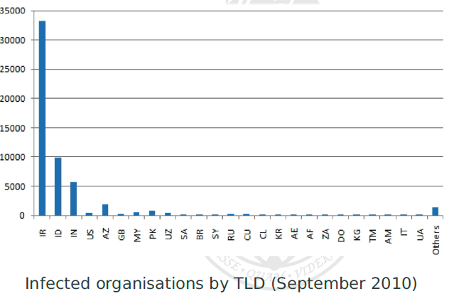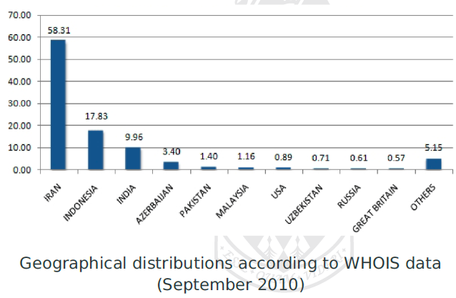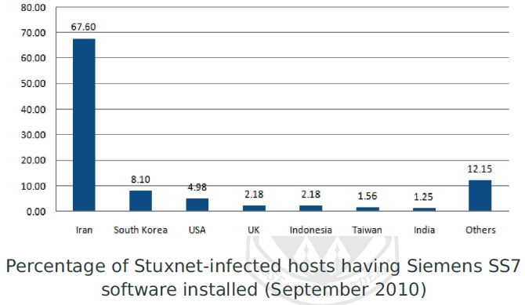

**Targets:**

Initial – affected Iranian company (dealing in industrial automation)

2nd – affected 2 other companies industrial automation (other attacks = compains in iran (UN sanction list)

Worldwide – propagation = Behpajooh Co.

Others – Neda Group (iran version of urenco design)

**High level Overview:**

* 32 exports, 15 resources
* External C & C
* Actual payload = siemens simatic Step 7
* Propagation mechanisms
* Attacks print spoolers, local Lnk file (USB), SMB network share

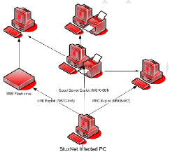

**Target Systems**

* HMI = main logic of malware
* Damage = PLC (programmable logic controller)
* Logic = gain access to HMI, conceal via rootkit, propagation = need admin priv
* Counter forensics/ IDS mechanism used
  + Loadlibrary with non-existent filename, hooking NTDLL.DLL
  + Hook uses the handcrafted filename to map files/filenames to different in-memory location
  + AV detected, code injection/obfuscation adapted accordingly
* Used innocent looking domains

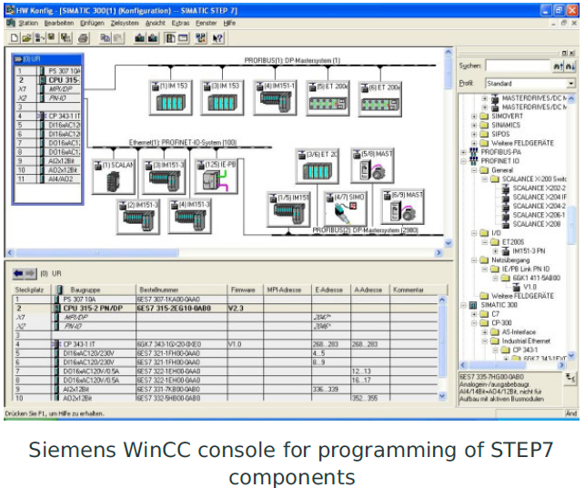

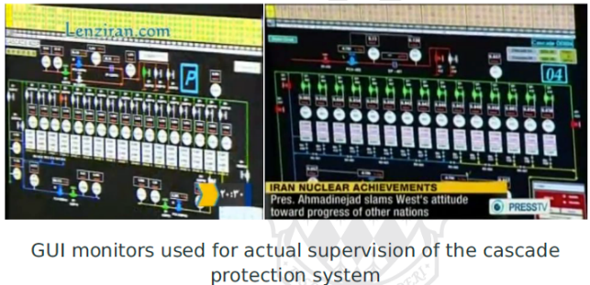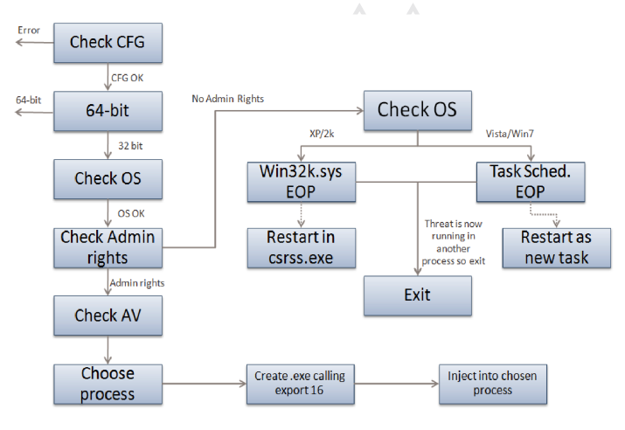

* Injects into trusted process (LSASS, WinLogon)
* Injection = call of exports
* Task scheduler (0-day atk = vista or later) MS10-092 (task info = userwritable XML, weak checksum, allow priv escalation to SYSTEM)

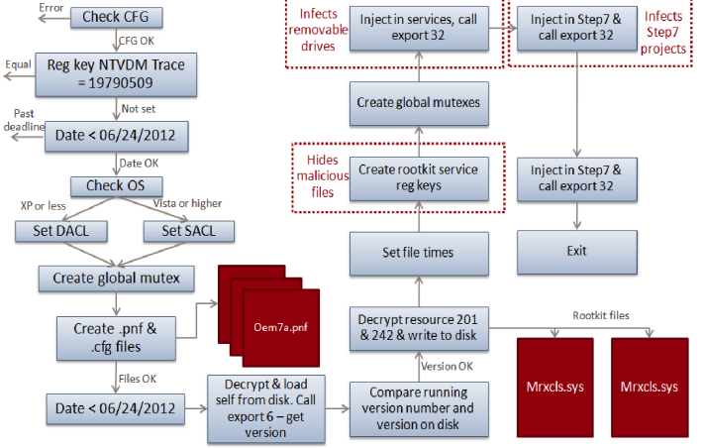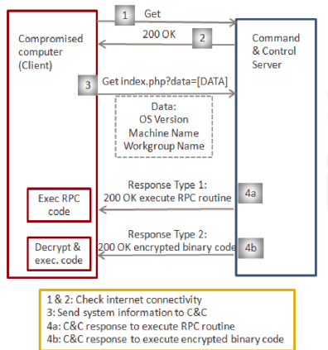

Network Attack Vectors (2 propagation)

* Accessible Network Shares
  + Computers with same user accounts as local users
  + Credentials for &admin and $c
  + Uploads stuxnet mothership DLL to victim, schedules task to execute DLL
* RPC vuln (MS08-67) buffer overflow, more sophisticated ROP variant

Print Spooler Vector (MS10-061)

* Precondition = shared printer installed on target, vuln allowed RCE
* Connect to print spooler as guest
* Print 2 mal doc to files %SYSTEM% directory
* Subsystem priv, rather than guest priv
* 1st file = winsta.exe, with stuxnet mothership DLL
* 2nd file = event leading of execution of 1st file

USB LNK Vector (MS10-046)

* Insertion of removable medium
* Data copied ~WTR4132.tmp, with LNL files, allow exploitation of different win versions
* Tightly coupled to rootkit functionality, new files not visible on infected machines, as early as possible

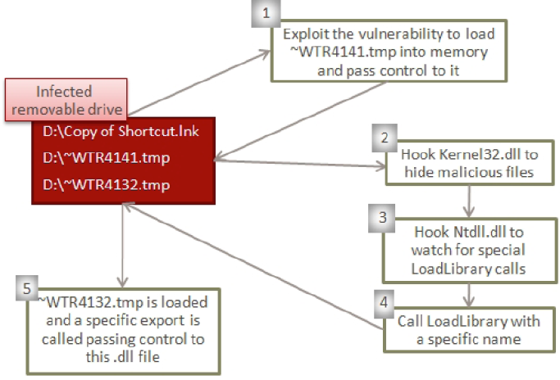

Windows Rootkit Functionality

* Hiding on removable storage media (impt for air-gapped systems)
* Device driver installed (serving as filter driver, for files matching stuxnet payload, using name & size)
* Other kernel (include AV, and user process), as files copied to removable media

Other methods

* P2p, updates, network shares, print spooler

Payload = easy, winCC = hardcoded db server pw

Rely on existing credentials (using default admin login, 2WSXcder)

* Decrypt from stuxnet main dll, insert into db
* Stored persistently via OLE automation stored procedure, added as a stored procedure for subsequent execution

PLC interception mechanism

* Replaced PLC code update/retrieval mechanism
  + HML = shows legit code

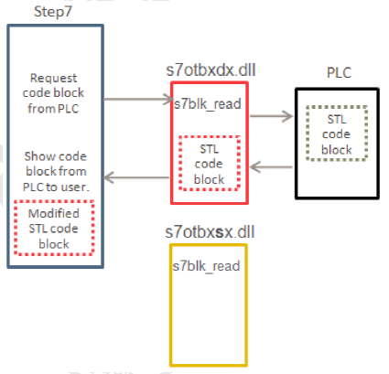

PLC Targets

Centrifuge cascade attack (Siemens S7-417 controller targeted)

* Pressure controller (PR-4000) = translation bridge
* Attackers = aware of number of pressure controller, and fraction controlling exhaust valves
* Targeting comm module controlling centrifuge drive system for rotor speed attack

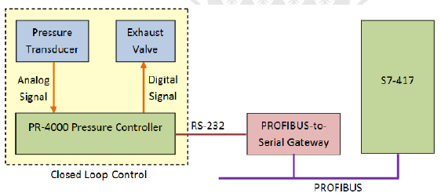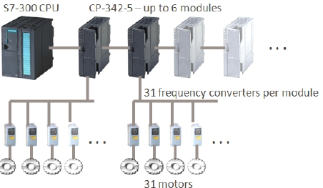

* Targeted systems with high freq (not used for civilians)
* Sabotage and over-speed controlled components

**Target**

2 design vulnerabilities

* Rotor (exceed critical rotor speeds)
* Isolation & exhaust valves (overpressure)

**Stuxnet target both vectors**

* Requires cascade of connected centrifuge, overpressure propagate across cascade
* Individual centrifuge = targeted

**Cyber-physical attacks**

2 attack mechanisms against gas centrifuges

1 attack vector = targets gas flows across cascade, control loops feed from exhaust valves to intakes of subsequent valves

* All signals = passthrough, except attack
* Attack blocks isolation valves for some enrichment stages preventing product & waste output
* Increase pressure in non-isolated centrifuge continuously
* Attack = pressure sensors are calibrated, and report sanitised reading, reporting normal readings

Over/Under speed of rotors = against indiv centrifuge

* Once a month, while report normal rotor speed
* Normal = 63k rpm
* Goes to 84600 for 15 min, then 120 rpm.
* Severe vibration, damage (cracked rotors)
* Failed centrifuge = pressure imbalance

Stuxnet suppress messages from sensors

Attack mechanism

* Look for PLC, inject according to version
* Simple pre-pending, malicious code before normal code
* Logic, further ops depends on exact attack

Can be monitored

* Learn normal behaviour, and playback before launching attack
* Generate attack, report normal speed, ignore further commands, wait several hours (for faults)
* Exact command seq depends on freq converters
* Automatic alerts for fail-safes = suppressed
* Selects random centrifuge, and over/under speed attack over a 7 min attack
* Repeated around 35 days

Malware

* Shared code = some codes used in other malware dated back from 2003
* Includes bootkit, persistence storage, mapping tools, intel gathering tools
* C&C = 300+ domains, 100+ servers, linux hosting, fraudulent DNS domain registration

**Flame Propagation**

* Partly operator-controlled, have semi-automatic bot-net propagation vector

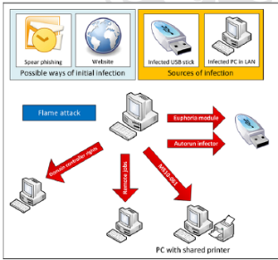

**Flame Functionality**

* Stuxnet = 500kb, flame = 20MB
* Comm over SSH/TLS
* Network/keyboard sniffing
* Interception of diff comms
* Intel gathering, harvest docs, PDF, MsOffice
* Collected info, uploaded to C&C
* Use forged cert for MS
* Setup false MsUpdate server

**Static Risk & Attack Models**

* Failure/attack = possible

**Assessment = likelihood & impact**

* Simple formula  
  risk = probability X expected loss

**Risk =** potential given threat will exploit vulnerabilities of asset/group cause harm to organisation

**FMEA (Failure Mode & Effects Analysis)** systematic process to identify failure

* **Design FMEA** functions of component
* **Process FMEA** examines processes

Terms:

* Basic function = critical sys functions
* Secondary function = non-critical func
* Failure mode = description
* Failure effect = impact
* Failure cause = cause

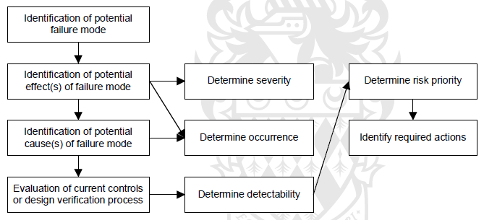

**Risk prioritisation** (based on variables)

* Severity – seriousness of effect
* Occurrence – rate of 1st level cause will occur
* Detection – likelihood controls will detect

Conducting

* Functional analysis (basic/secondary function)
* Identify Failure mode (primary ones)
* Determine severity, occurrence

*use diagram/wsheets, not for complex failure cascades

**Fault & Attack Tree**

* **FTA =** system-oriented, top-down analysis
* **Common** for **casual**  analysis of reliability&risk

Attack tree = term adjustments, underlying = same

Construction

* Select system-level failure = top event
* Immediate causes (of failure)
* Repeated recursively till component/atomic
* Similar causes grouped by logic gates
* May start from higher level FMEA

Set boundary/scope condition

Cut set = minimal events that make top level event fail

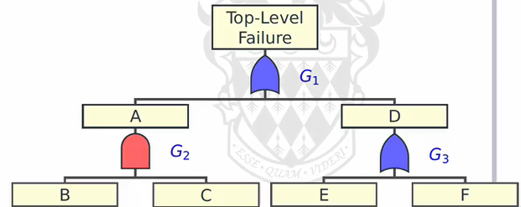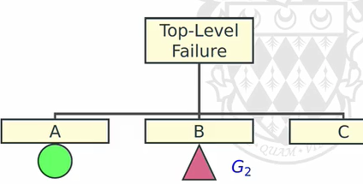

**Quantitative Assessment =** calculate probability based on AND or OR gates.

* Find the probability of cut set
* Cut sets need not be independent

Event type: **Non-repairable / Repairable / Periodically-tested**

* Repairable = factor in MTTR
* P-tested = Failure only detected during test

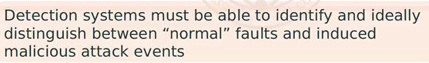

**Limitation** of Attack tree

* Static   
  (cannot capture interaction btwn atk & dfer)
* Overly/under defensive
* Limited by amount of info that can be represented

**Dynamic Attack & Adversary Model**

**Attack-Defence Tree** (attack node + defence node)

* Refined to give further detail (till basic action)
  + Child node, opposing node

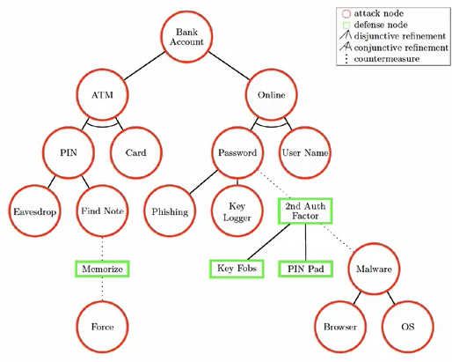

* Conjunctive = AND

**Attack countermeasure Tree (adds mitigating measures)**

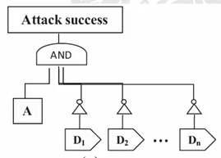 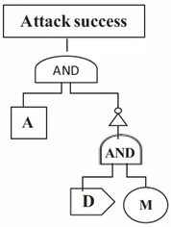

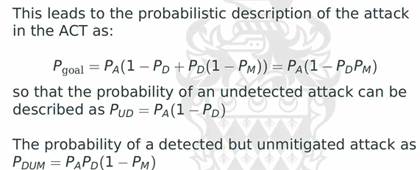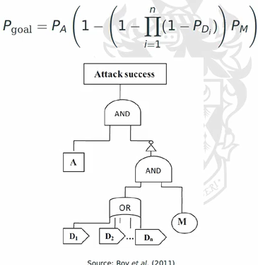

Allows combination of multiple detection + mitigation (parallel)

Limitation probability = from where ?

Most impt = cut sets (describes attack CT scenarios)

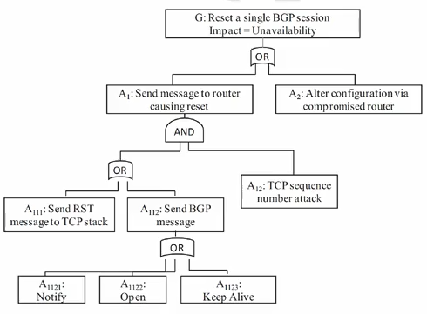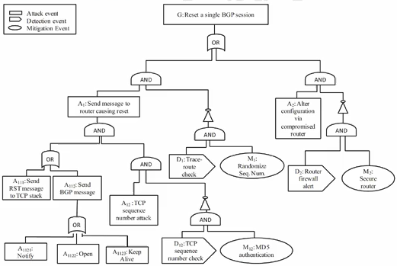

**Game Theoretical Attack Models**

Game theory = intuitive model for adversarial & co-op

* Which strat should employ
* Prisoner’s dilemma
* Hawk & Dove (confrontational/conciliatory)

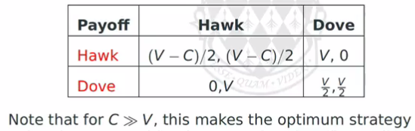

Players = rational + selfish (best possible)

* Joint behaviour of variables
* Strategies > probabilities

**Equilibrium** = strategic standoff

**Game Theory Model**

* N players
* Set of M basic actions / pure strat
* Grouped in form of joint actions
* Trues to **maximise** indiv PAYOFF

**Mixed Strategies**

* Probabilities of pure strategies
* Expected return 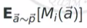

**Nash equilibrium (simplest)** = no comm/bargaining

* No player must have incentive to deviate from his optimum strat
* NE always exist in mixed strat
* Can announce in advance
* May have multiple

*No further comm allowed, no further collusion beyond shared info

- Simplest = zero-sum  
- harder when more players

Extension: repeated games (cumulative)

* Regret minimisation (converge to NE)
* Allow previous state

**Stackelberg Competition**

* Capture interaction (Atker & Defer)
* Leader take action, observed by follower
* Result = can be NE, does not need
* Atker = multiple potential target, dictate allocation of resources

**When & How to defend**

* Competition over shared resource
* Players can move any time
* Move = associated with cost
* Allow optimal strat for defender

**Concurrency in Adversary Model**

**Mix =** give probabilities

**Pure =** not the best (allow atker to respond optimally)

Problem = concurrency / time-dependency (coordination, certain order)

**Petri Nets =** intuitive graphical + mathematical modelling of concurrency

* Capture async concurrent behaviour + natural formulation for distributed & parallel   
  (can be nondeterministic)

**Bipartite graph**

* Places (resources / state)
* Transitions (transitions/sync events)
* Tokens ( current state, finite num)

Transition = enabled ( can fire, atomic)

* Fire = removed and added

Security wise:

* Security states = places
* Attacker’s action = transitions
* Can be expanded (with defensive actions)
* Complex attack (use multiple tokens)
  + Ordering = require additional transition
* Useful if small/fine grain details
* Capture sig lvl of detail abt attacks
* Visual + efficient computation
  + Communication of atk scenario

Extensions:

* Hierarchical Petri Nets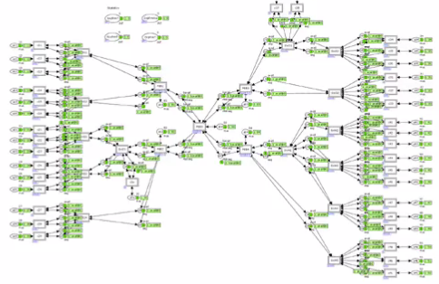
* Coloured Petri Nets (show ordering)
* Timed Petri Nets